Clear metro signage, for all travelers

This article takes a closer look at the wayfinding system in the Amsterdam metro. It’s a highly thought-out system that plays a vital role in helping around 275,000 travelers find their way through 39 stations each day. These travelers include people of all ages: locals and visitors, students, commuters, and tourists. They come from different cultural and language backgrounds, and they all have different needs and abilities. Some know the metro like the back of their hand, others are using it for the very first time. The signage needs to be clear and understandable — for all of them.

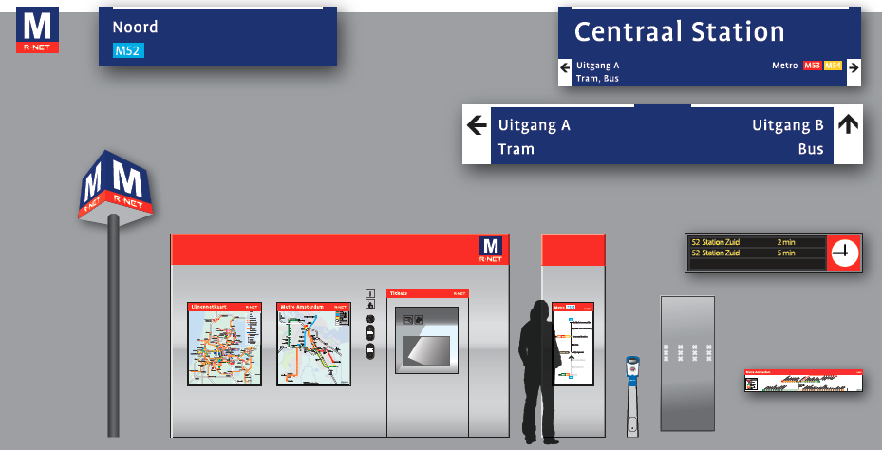

Which way to go?
The directional signs in the metro stations guide passengers to platforms, exits, and other facilities. The signs use Dutch words and arrows to indicate where to go. But how clear are they for someone who doesn’t speak Dutch, or for someone with limited reading skills? (There are more than two million low-literate adults in the Netherlands.)

In places like train stations, pictograms are often used to help make information clear and language independent. At Schiphol Airport, English terms are added to the Dutch text. Could such strategies also work in the Amsterdam metro?

That’s the question Amsterdam’s regional transport authority (Vervoerregio Amsterdam, or VRA) brought to Mijksenaar. To answer it, we conducted user research with people from various backgrounds.

Research question:
How understandable is the current Dutch-only signage for different user groups, and could it be improved by adding pictograms or translations?

The research took place between 2023 and 2024. In May 2025, the first signs in the new style were installed at Amstelveenseweg station. This article outlines the research process and how the new design came about.

The research

Designing alternatives
We began by designing possible alternatives to the current signage. Our goal was not to start from scratch, but to build on the existing system, using the same colours, typography, and sign formats. This would allow for a phased rollout without replacing all the lightboxes at once; a more sustainable and cost-efficient approach.
Mijksenaar developed two new variants:
- With only pictograms
- Combining pictograms with text

In the second version, we added the English word Exit to the Dutch word Uitgang. For most other destinations, English additions wouldn’t add much value: terms like Bus, Tram, and Lift are nearly identical in Dutch and English. That’s also why the original design didn’t include English translations.
We compared both new versions with the current Dutch-only signs.

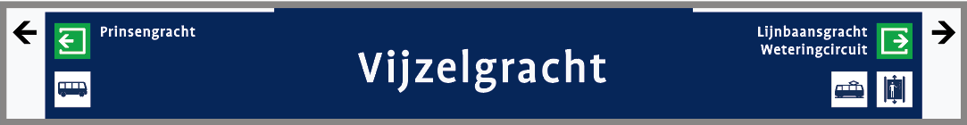
Version ‘Pictograms'

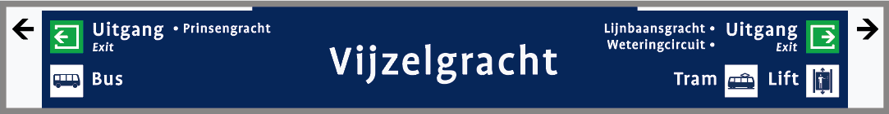
Version ‘Combined’

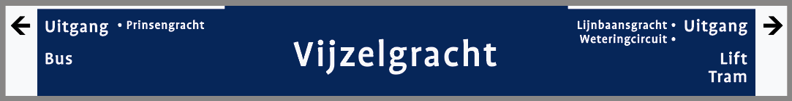
Current situation ‘Text only’

Target groups
We tested the signage with participants from three target groups. These were groups for whom the current signage might not be fully clear and who might benefit from the additions:
- People with a mild intellectual disability (6 participants)
- People with low literacy (4 participants)
- People who don’t speak Dutch (20 participants)

Tests
Participants were asked to complete a navigation task using images of the three sign variants, either on paper or an iPad. For each version, they answered practical questions like: ‘Which direction should you go for the exit?’. After the task, we talked with them about their experience and preferences.

Results

Navigation performance
The navigation task gave us a nuanced, and sometimes surprising, picture. The combination of text and pictograms performed best, with a 100% correct score: every participant gave the right answer every time.

The text-only signs came in second, with an average of 95% correct. Some non-native speakers struggled more with this version, while the other two groups performed very well, scoring 100% correct.

The pictogram-only signs caused occasional confusion across all groups and scored 81% on average.

Experience
But wayfinding isn’t just about getting it right, it’s also about how confident and comfortable people feel while navigating. That’s why we asked participants about their experience with the three sign types.

Preferences
We asked participants which variant they liked most and least. The combination variant came out clearly on top. Most participants liked having information presented in two ways: both text and image. These formats could support each other and offer reassurance. Some participants with low literacy or intellectual disabilities said that they often look for reassurance while travelling, and that this combination gave them exactly that.

Interestingly, even though the pictogram-only version was understood the least, it wasn’t the least liked. That turned out to be the text-only variant.

Pros and cons
So, is the combination variant the best solution? It certainly performed best and was the most preferred. But things aren’t quite that simple.
In conversations, participants pointed out some important drawbacks of this variant. Adding both text and pictograms made some signs feel ‘full’ or ‘busy’. This can reduce clarity, especially in crowded, high-stimulus environments like metro stations. During the test, participants viewed the signs up close and in a calm setting. But real-life metro conditions involve distractions like announcements, advertisements, crowds, and time pressure.
Another downside was that combining two types of information meant each element had to be slightly smaller to fit the fixed sign dimensions. Several participants said they’d prefer larger text and symbols to make information easier to read from a distance.
In other words: the most understandable and preferred version also risked being the most cluttered.
The research not only offered valuable insights, but also presented a clear design challenge:
How can we combine the best of both worlds: more clarity through both text and pictograms, without losing clarity and legibility?

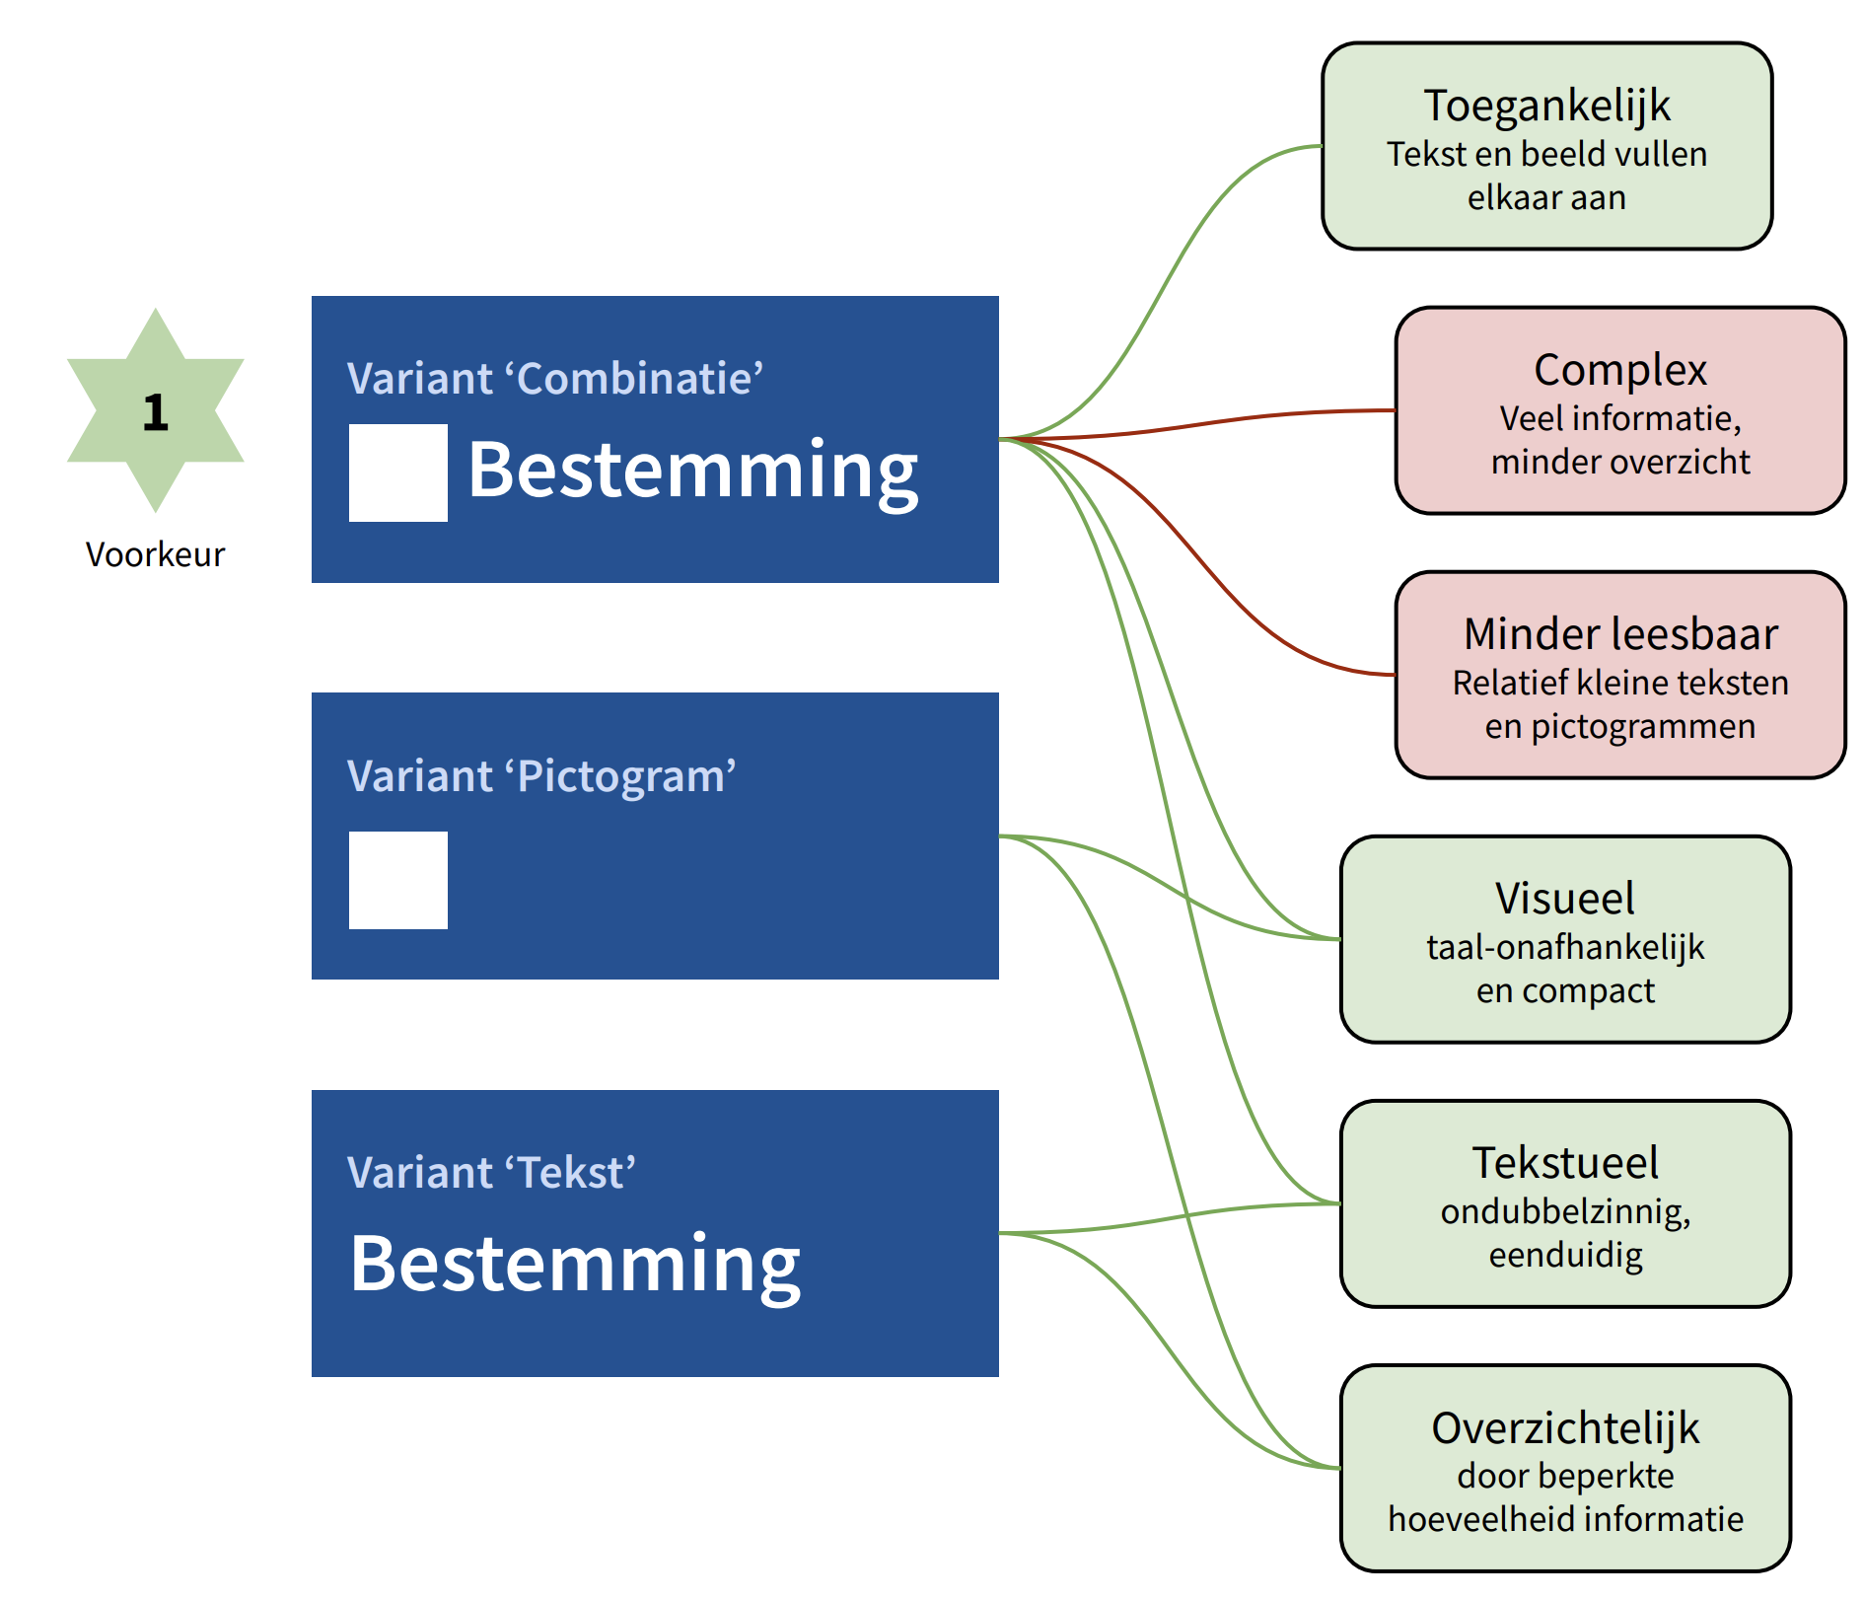

The new design
In the next phase of the research, we selected signs from larger metro stations that tend to display the most information. On these, we tested different design options.

In particular, we found that combining multiple pictograms and text elements on a single line often resulted in cluttered, less readable signs. But using multiple lines wasn’t feasible either: it would mean taller signs, and that wasn’t an option in some stations due to low ceilings and fixed light box dimensions.

To keep things clear and simple, we decided to limit the number of pictograms to one per line. That meant not every destination would get a pictogram - only those where it added the most value. But which destinations are those?

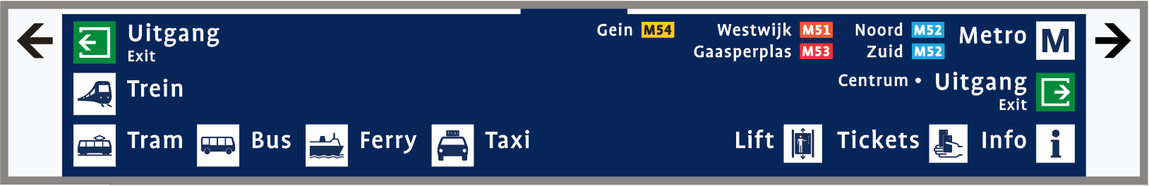
Multiple pictograms on one line result in a complex and cluttered sign.

The research showed that directions towards the exit were a key source of confusion. Many non-Dutch speakers didn’t understand the word Uitgang. And the existing exit pictogram was also not always clear, for participants in all three groups. So it was decided to add both the pictogram and the word Exit. If someone doesn’t recognise the pictogram, the texts provides clarity. And the internationally recognised Exit reinforces the message — especially for non-Dutch speakers.

We also added both an English term and a pictogram to all metro references. While the familiar ‘M’ symbol isn’t strictly a pictogram, it’s a highly recognisable element for metro users, and one that also appears in the streetscape at metro station entrances. It helps visually distinguish metro references from other forms of public transport, such as train, tram, or bus. The word ‘Subway’ was added after we found that some travellers, particularly from the UK, didn’t recognise the term ‘Metro’.

Finally, the study showed that not all non-Dutch-speaking participants understood the word Lift. That is why lifts will now be indicated using both text and a pictogram.

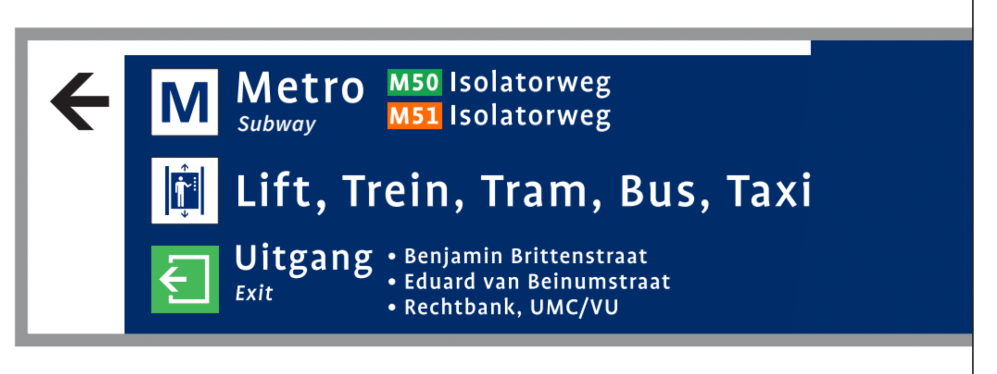
s

Clear and understandable
The new design is the result of a careful, iterative design process, with research insights guiding every step. The aim was to combine the benefits of different approaches — without sacrificing clarity or usability.

Simplicity
The number of elements per sign is kept low to prevent visual clutter and complexity.

Clarity
The layout follows a consistent structure. Each line includes no more than one pictogram, helping create rhythm and overview.

Comprehension
The original Dutch text is retained. Where text isn’t clear for all users, a pictogram is added. The two formats reinforce one another.

Accessibility
In addition to a pictogram, the internationally familiar term Exit is added to help non-Dutch speakers understand the meaning.

Implementation
The updated design matches the existing visual style, using the same colours, fonts, and formats. This means current light boxes can stay, and the rollout can be done step by step.

Acknowldegments
This project was carried out in close collaboration with several partners, whom we sincerely thank for their valuable contributions and expertise. The research with participants with a mild intellectual disability was conducted together with Stichting MEE Amstel en Zaan, and the research with low-literacy participants in collaboration with Stichting ABC. Throughout the project, we worked closely with our client Vervoerregio Amsterdam (VRA) and key stakeholder GVB. Last but not least, we thank all participants for their contribution.

